**What’s the MEAN Stack?**

*MEAN* is an acronym made up of commonly used technologies for an all JavaScript web stack/full stack. You don’t have to use this combination and there are many alternative choices, especially on the client-side such as Backbone, Ember etc.

This particular combination of tools has generated a lot of traction in the enterprise area and is framework based, making it a good place to start.

The key components are:

* **M**ongoDB (Database)
* **E**xpressJS (Web Framework)
* **A**ngularJS (Front-end Framework)
* **N**odeJS (Application Server)

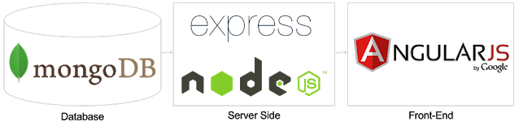

## Why MEAN Stack?

The acronym "MEAN" stands for "MongoDB Express.js AngularJS Node.js" and represents a group of technologies which are known to synergize well together. The major benefit of the MEAN stack is that it's extremely quick to prototype with. Node.js allows you to use Javascript on the backend as well as the frontend which can save you from having to learn a separate language. In addition, the NoSQL nature of MongoDB allows you to quickly change and alter the data layer without having to worry about migrations, which is a very valuable attribute when you're trying to build a product without clear specifications. Finally, these technologies have a lot of community support behind them so finding answers to questions or hiring help is going to be much easier using these technologies.

Using following command :

$ npm uninstall -g @angular/cli

$ npm cache clean

$ npm install -g @angular/cli

**Notes :**

* On Windows run this using **administrator**
* On Mac use **sudo** ($ sudo <command>)
* If you are using npm>5 you may need to use cache verify instead. ($ npm cache verify)